Award ID: 00080290-CCCPA Phase II
Enhancing the Capacity of Local Actors in Efforts to Improve Peace and Stability in North Africa, the Sahel and Great Lakes

Second Quarterly Report

1 June–31August 2014

Table Of Content

Item | Page
Introduction ……………………………………………………………………………………………………. | 3
Project Issues …………………………………………………………………………………………………. | 4
Project Performance | 5
- OUTPUT 1: Improved Knowledge in Border Management in North Africa and the Sahel……………………………………………………………………………. | 5
- OUTPUT 2: Greater Understanding of, and Improved Skills in, Peacekeeping and Peacebuilding Issues in North Africa, the Sahel and Great Lakes…………………………………………………………………………………………. | 10
- OUTPUT 3: Improved Knowledge and Skills in Conflict Resolution and Crisis Management in North Africa, the Sahel and Great Lakes…………… | 13
- OUTPUT 4: Establishment and Operation of a Project Management Unit ……………………………………………………………………………………………………. | 23
Financial Situation…………………………………………………………………………………………… | 25
ANNEXES ………………………………………………………………………………………………………… | 26
- List of Training Workshops Scheduled for the Next Quarter (September-November 2014)……………………………………………………………… | 27
- ANNEX II: Evaluation Tools …………………………………………………………………. | 28
- ANNEX III: Media Coverage…………………………………………………………………. | 38

Introduction

The Egyptian Ministry of Foreign Affairs established the Cairo Center for Conflict Resolution and Peacekeeping in Africa (“CCCPA” or “the Center”) in 1994. Establishment of the Center was in line with Egypt’s sense of responsibility towards achieving peace and security in Africa, including building African capacities, and a natural extension of its role as a champion of pan-African causes. In recognition of its contribution to African peace and security, the Center is now among a few centers on the continent recognized by the African Union (AU) as Centers of Excellence in Training in peacekeeping. In addition, it is the sole provider of mandated training for the North African Brigade of the African Standby Force (ASF) and the only Arab civilian center of its kind to provide integrated, multidimensional training to the military, police and civilians.

The importance of CCCPA’s work in enhancing African local capacities in peace and security cannot be overestimated, because despite the huge efforts of the international community, Africa continues to be conflict-ridden, with devastating consequences on Human Security and serious repercussions for Global Peace. On one hand, some North African countries continue to struggle as a result of the socioeconomic/political upheavals of the last three years, with protracted transitions and mounting threats to peace and security, including state failure, porous borders and terrorism. On the other hand, the Sahel/Sahara and Great Lakes regions continue to suffer from a plethora of longstanding and complex sources of insecurity and instability. Facing such challenges requires the cooperation of countries in these regions that are pillars of security and stability, such as Egypt and leading global powers, such as Japan.

Since 2008, CCCPA has received support from the Government of Japan (“GoJ”) through the United Nations Development Programme (UNDP). Up to 2013, the support provided was critical in strengthening the Center’s institutional capacity and improving its ability to contributing to building the capacities of other African local actors in areas of peace and security. Since May 2014, and the signing of the project “Enhancing the Capacity of Local Actors in Efforts to Improve Peace and Stability in North Africa, the Sahel and Great Lakes” (hereafter referred to as “the Project”), the support of the GoJ to CCCPA has entered a new phase, whereby the financial burden of sustaining CCCPA’s institutional capabilities has been increasingly shouldered by CCCPA itself, freeing resources available through the Project to:

- expand the scope and maximize the impact/visibility of the trainings provided on (i) building/enhancing the capacities of African regional, national and local actors in areas of border management; (ii) peacekeeping and peacebuilding; (iii) conflict resolution and crisis management - to ensure they have the necessary skills for appropriate and timely responses to incidents that threaten peace and stability
- respond to traditional and emerging threats to the different aspects of security in Africa - such as the Ebola outbreak in Western Africa; and
- improve the quality of the training experience - including partnering with world-class expertise.

As outlined in the Project’s document, the expected outputs are:
(i) Improved Knowledge in Border Management in North Africa and the Sahel – Output no.1
(ii)Greater Understanding of, and improved Skills in, Peacekeeping and Peacebuilding Issues in North Africa, the Sahel and Great Lakes – Output no.2
(iii) Improved Knowledge and Skills in Conflict Resolution and Crisis Management in North Africa, the Sahel and Great Lakes – Output no.3
(iv)Establishment and Operation of a Project Management Unit – Output no. 4

During this quarter (June-August), CCCPA successfully conducted four training programs: three on “Media and Conflict” (Output no. 3) and one on “Human Trafficking” (Output no. 1). The trainings were attended by 122 participants from 15 countries, and different professional backgrounds -almost half of which were female. In preparation for these trainings, CCCPA collaborated with two leading international organizations, namely the United Nations Educational, Scientific and Cultural Organization (UNESCO) and the International Organization for Migration (IOM). These partnerships have ensured that trainings were conducted professionally and that methods of delivery and training materials were state of the art.

Additionally, we began preparations for another 13 activities that will be conducted during the Q3 of the Project (1 September- 30 November 2014): four courses for output no.1; six for output no.2 and three for output no. 3. In addition, CCCPA will be commissioning four research papers on Disarmament, Demobilization, and Reintegration (DDR) experience in Sudan; the Protection of Journalists in Conflict Areas; Human Trafficking in North Africa; and North Africa in Transition.

This quarter also witnessed some major political and security developments in the regions covered, with strategic and operational implications on the Project. The outbreak of the Ebola virus and the limitations imposed on travelling from and to the affected countries, has limited, to a certain extent, the ability of trainees from these countries to participate in CCCPA’s activities. The worsening security situation in Libya has also had the same impact, affecting not only Libyan participation in the Center’s activities, but also opportunities for collaboration with state institutions in Libya (notably in the area of border management). This situation is unfortunately expected to continue in the near future. CCCPA is closely monitoring the situation in Libya, as well as regional and international initiatives, such as meetings of Libya’s Neighboring Countries, to extrapolate possibilities of enhancing Libyan capacities. However, on the positive side, this quarter witnessed the resumption of Egypt’s active membership in the AU, which was temporarily suspended in August 2013.

This report presents the main activities of the Project during the period from June 1stto August 31st2014 (Q2 of the Project).

1. Project Issues
Updated Project Risks  This quarter overlapped with the holy month of Ramadan in Egypt and the Arab/Islamic world, in addition to summer breaks, which presented the risk of a low turnout for CCCPA’s activities. Nevertheless, and as a result of thorough planning, most of this risk was averted, limiting the number of cancellations and late arrivals to a minimum. |  |  |  |  | Updated Project Issues  Egypt resumed its activity in the AU, following a suspension that lasted for less than a year following the June 30 Revolution. Egypt’s return to the AU will further enhance the Center’s ability to take the lead in some important training activities within the AU, as well as provide enhanced opportunities for substantial contribution to the upcoming reviews of the global peacekeeping and peacebuilding architecture.
2. Project Performance

OUTPUT 1: Improved Knowledge in Border Management in North Africa and the Sahel

Deliverable Description:
During this quarter, CCCPA successfully conducted one training to improve skills in Human Trafficking in North Africa, the Sahel and Great Lakes. The training was attended by 18 participants (15 males and 3 females), from four countries and different media organizations. Additionally, preparation for four courses in Human Trafficking, Small Arms and Light Weapons (SALW) and Integrated Border Management has been completed.
Planned training for Q3 of the Project:
- Training on Human Trafficking for North Africa & Sahel;
- Training on SALW for North Africa and Sahel;
- Training on Border Management for North Africa &Sahel; and
- Training on Human Trafficking for North Africa &Sahel.
Target: March 2014 – February 2015
Achievement of: June-August 2014

Activity ID: Activity Result 1-1: Developed training methodology, curricula and partnerships
Deliverable Description:
During this quarter, CCCPA identified possible consultants who will be assisting in the technical training programs and curriculum development. The hiring process will take place during Q3 of the Project.

Indicators:
- Number of Technical Staff Recruited
During this quarter, CCCPA interviewed several potential research officers to support border management research activities. The hiring process will take place during Q3 of the Project.

- Number of Coordination Meetings with Counterparts Conducted

Aseries of consultations were held between CCCPA and IOM, the result of which was a training course for peacekeepers on Human Trafficking following an International Human Rights Law approach and framework, including international migration law, standards and principles of international protection and best practices in the fields of victim identification and assistance in the training. Separate consultations were held with the United Nations Office on Drugs and Crime (UNODC) for future cooperation in conducting training on human trafficking.

Additionally, a mission was conducted in Geneva on 2 and 3 July 2014. Meetings were held with The Small Arms Survey, an independent research project located at the Graduate Institute of International and Development Studies in Geneva, to explore areas of potential cooperation in training on combating SALW. Another meeting was held with The United Nations Institute for Disarmament Research (a voluntarily funded autonomous institute within the UN) to discuss similar cooperation. Moreover, CCCPA participated in discussions held in Algeria from 4-6 June 2014 on transnational threats in North Africa, which tackled border management issues in the region and their impact on the Sahel and Sahara.
- Number of Research Areas Identified
This indicator was achieved during Q1 of the Project (1 March – 31 May 2014).

- Number of Appropriate Implementing Partners Identified
CCCPA cooperated with the IOM to conduct a joint training on “Human Trafficking and Border Management”.

- Number of Consultation Workshops with Implementing Partners Conducted
During this quarter, two preparation meetings were held with the IOM and UNODC to identify themes for the human trafficking training workshop.

- Number of Briefing Papers Developed
Following the identification of the research areas of border management, a technical meeting was held to outline the research materials. One research material is to be published on the topic of human trafficking.

- Number of Training/Workshop Programs Designed
Meetings were held with the IOM to finalize the training manual and the handouts in the human trafficking training.
Current Evaluation:
Start and End Date: March 2014- February 2015
Percentage Progress to date: 30%
Quality Criteria |  | Date |  | Results of Activities
 |  |  |  | User Perspective |  |  |  |  |  |  |  | Resource Status |  |  |  |  | Timeliness
Financial Summary -in USD
Account | Fund | Donor | R. Party |  |  |  | Budget |  |  |  |  | Expenditure |  |  |  | Balance
 | GoJ | GoJ |  |  |  |  | 114,126.69 |  |  |  |  |  |  |  |  | 110,520.86
71405 |  |  |  |  |  |  |  |  |  |  |  | 3,356.42
73500 |  |  |  |  |  |  |  |  |  |  |  | 249.41
Activity ID: Activity Result 1-2: Trainings/workshops in the following areas:
- Border Management Mechanisms
- Small Arms and Light Weapons
- Human Trafficking

Deliverable Description:

One training course was conducted (Combating Human Trafficking) in cooperation with the IOM. The training was held at the Fairmont Nile City Hotel from 31 August – 3 September2014.

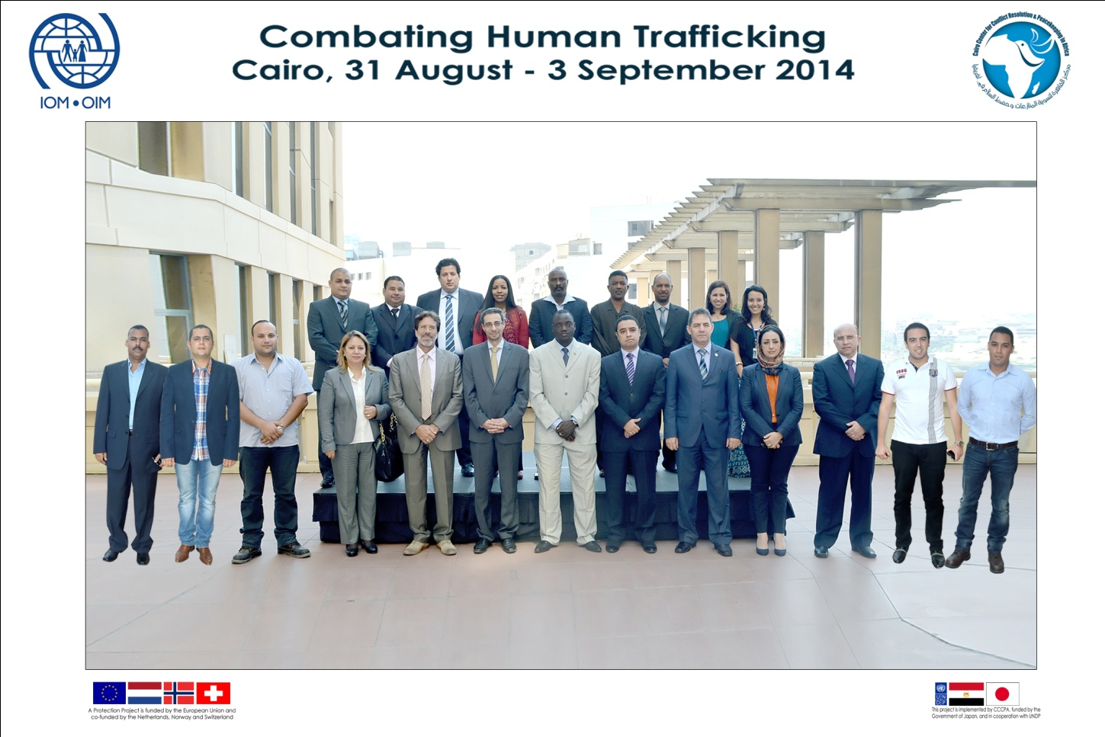

Indicators
- Number of Participants Trained on Border Management (Country and Gender Disaggregated)
Number of Participants | Men | Women
18 | 15 | 3

Countries
Egypt | Mali | Libya | Sudan
12 | 1 | 2 | 3

- Number of Workshops/Trainings Organized on Border Management Topics
One training workshop conducted on Human Trafficking

Current evaluation:
Start and End Date: June 2014 -February 2015
% Progress to date: 10%
Quality Criteria |  | Date | Results of Activities
 |  |  | User Perspective |  | Resource Status | Timeliness
Financial Summary- in USD
Account | Fund | Donor | R. Party | Budget | Expenditure | Balance
 | GoJ | GoJ |  | 420,000 |  | 417,383
71615 |  |  |  |  | 2,617

Activity ID: Activity Result 1-3: Operational platform and mechanism to evaluate, follow-up and outreach with training alumni

Deliverable Description:
Indicators
- Database of Participants Developed
This indicator was achieved during Q1 of the Project.
- Monitoring and Evaluation Mechanisms Developed
This indicator was achieved during Q1 of the Project.
- Knowledge Gained by Participants as Measured (end of course evaluation)
Through participating in this training workshop, the participants have gained knowledge and skills in the various aspects of human trafficking. Almost all participants think that the course will assist them in their future work and that they will be able to use some of the new procedures learnt. 100% of the participants demonstrate or perceive their improved knowledge.
“The training adapts a diplomatic way of handling sensitive arguments about human trafficking and an open environment for sharing thoughts”

Participants’ Perception Questionnaire (Level 1)
Scale:5=Strongly Agree 4=Agree for the Most Part 3=Somewhat Agree 2=Agree Only Slightly 1=Disagree
Evaluation | Rating (Average)
Course Objectives & Content | 4.5
Training Materials | 4.3
Trainers’ Skills | 4.3
Course Administration | 4
Accommodation and Training Room | 4.2

- Follow-up Group with Available Participants and Partners to Assess Impact Conducted
Implementation was not scheduled during Q2 of the Project
Current evaluation:
Start and End Date: March 2014- February 2015
% Progress to date: 100%
Quality Criteria |  | Date |  | Results of Activities
 |  |  |  | User Perspective |  |  |  | Resource Status |  |  |  |  | Timeliness
Financial Summary– in USD
Account | Fund | Donor | R. Party |  |  |  | Budget |  | Expenditure |  |  |  | Balance
 | GoJ | GoJ |  |  |  |  | 15,000 |  | 0 |  |  |  | 15,000
OUTPUT 2: Greater Understanding of, and Improved Skills in, Peacekeeping and Peacebuilding Issues in North Africa, the Sahel and Great Lakes

Deliverable Description:

CCCPA resumed activities related to peacekeeping and peacebuilding in the three main regions of interest - North Africa; the Sahel and Sahara; and Great Lakes. The Center also began preparations for three courses, which will be conducted duringQ3 of the Project, and are expected to be attended by 65 participants.
These will include:
- Workshop on “Issues of Transition for the North Africa Region”
- Training of the African Union Senior Mission Leaders;
- Training on DDR in North Africa, the Sahel, and Great Lakes - in cooperation with the International Peace Support Training Center (IPSTC) in Nairobi;
- Training of Trainers on DDR in North Africa, the Sahel, and Great Lakes - in cooperation with the International Peace Support Training Center (IPSTC) in Nairobi;
- Workshop on the “African Perspective and Regional Aspects of Peacebuilding” - in cooperation with the Egyptian Ministry of Foreign Affairs and the UN Peacebuilding Support Office. This workshop will be attended by high level Peacebuilding officials; and
- Workshop on Peacebuilding in North Africa: The first meeting of Libyan tribal leaders.

Target: March-May 2014
Achievement of: June-August 2014
Activity ID: Activity Result 2-1: Development of training methodology, curricula and partnerships

Deliverable Description:

During this quarter, CCCPA interviewed possible researchers who will be assisting in the technical training programs and curriculum development. Furthermore, the Center developed its curriculums on DDR for North Africa; this was done in cooperation with the Sudan National Committee on DDR. Furthermore, CCCPA embarked on efforts to hold a workshop on “North Africa in Transition”, to discuss various political, economic, and social topics - participants from Egypt, Libya, Algeria, Tunisia and Morocco have confirmed their participation.

Additionally, CCCPA updated a tailored curriculum for pre-deployment, which targets Egyptian troops sent to participate within the United Nations Mission in Mali (UNISMA). In line with current efforts on a global scale to assess and review the United Nations Peacebuilding Architecture, CCCPA also finalized its consultations with the UN Peacebuilding Office (PBO). CCCPA expects to organizea high-level workshop on peacebuilding efforts on 24 and 25 November 2014; the workshop will tackle the main issues from an African perspective.

Indicators
- Number of Technical Staff Recruited
During this quarter, CCCPA interviewed several potential research officers to support peacekeeping and peacebuilding activities. The hiring process will take place during Q3 of the Project.

- Number of Research/Situation Analyses Developed
During this quarter, CCCPA identified several research areas in order to provide training on peacekeeping and peacebuilding, as well as transitional issues. CCCPA held a meeting with the United Nations Institute for Training and Research (UNITAR) (a training arm of the United Nations System) to discuss the possibility of partnering in implementing training courses on the protection of civilians in peacekeeping and peacebuilding operations in Africa.

CCCPA also participated in the annual meeting of the PeaceCap Network in Istanbul in July 2014, which discussed research topics related to peacekeeping and peacebuilding. During the meeting, CCCPA agreed to host the upcoming PeaceCap meeting - scheduled to take place in the second week of December 2014 in Cairo. In addition, CCCPA and the Sudanese National Commission of DDR discussed possibilities of issuing a publication in Arabic on DDR and the Sudanese DDR experience. Finally, CCCPA finalized contacts with the African Union Commission (AUC) to prepare for the upcoming senior mission leaders trainings - scheduled to take place during October.

- Number of Training/Workshop Programs Designed
Meetings were held with technical consultants to carry out this activity.

- Number of research materials published
Following the identification of research areas related to conflict resolution and crisis management, a technical meeting was held to outline the research materials. One research material is to be published covering “North Africa in Transition”. Furthermore, CCCPA and the United States Institute of Peace (USIP) discussed possible cooperation on research and publications, and accordingly a meeting was planned for September 2014.
Current evaluation:
Start and End Date: May 2014 – February 2015
% Progress to date: 20%
Quality Criteria |  |  | Date |  |  | Results of Activities
 |  |  |  |  |  | User Perspective |  |  |  |  | Resource Status |  |  |  | Timeliness
Financial Summary – in USD
Account | Fund | Donor | R. Party |  |  |  | Budget |  |  |  | Expenditure |  |  |  | Balance
 | GoJ | GoJ |  |  |  |  | 81,335.48 |  |  |  |  |  |  |  | 71,047.86
71615 |  |  |  |  |  |  |  |  |  |  | 693
72510 |  |  |  |  |  |  |  |  |  |  | 1,483.29
71405 |  |  |  |  |  |  |  |  |  |  | 8,111.33
Activity ID: Activity Result 2-2: Training programs &workshops in the following areas:
- Human Rights
- Rule of Law
- Transitional Justice
- Transitional Issues

Deliverable Description:
Due to the current, unstable situation facing some of the target groups of this output, the activity has been postponed to Q4 of 2014 (Q3 of the Project).

Indicators
- Number of Participants Trained in Peacekeeping and Peacebuilding (Disaggregated by Gender and Country)
- Number of Workshops/Trainings Conducted on Peacekeeping and Peacebuilding Topics

Current evaluation:
Start and End Date: May 2014 – February 2015
% Progress to date: 15% (one out of 12 trainings /workshops)
Quality Criteria |  |  | Date |  | Results of Activities
 |  |  |  |  | User Perspective |  |  |  | Resource Status |  |  |  |  |  | Timeliness
Financial Summary - USD
Account | Fund | Donor | R. Party |  |  |  | Budget |  |  | Expenditure |  |  |  |  | Balance
 | GoJ | GoJ |  |  |  |  | 325,229.61 |  |  |  |  |  |  |  | 325,229.61
Activity ID: Activity Result 2-3: Operational platform and mechanism to evaluate, follow-up and outreach with training alumni

Deliverable Description:
Indicators
- Database of Participants Developed
This indicator was achieved during Q1 of the Project.
- Monitoring and Evaluation Mechanisms Developed
This indicator was achieved during Q1 of the Project.
- Knowledge Gained by Participants as Measured (end of course evaluation)
Due to the current, unstable situation facing some of the target groups of this output, the activity has been postponed to Q4 of 2014 (Q3 of the Project).
- Follow-up group with Available Participants and Partners to Assess Impact Conducted
Implementation was not scheduled during Q2 of the Project.

Current evaluation:
Start and End Date: May 2014 – February 2015
% Progress to date: 50%
Quality Criteria |  |  | Date |  | Results of Activities
 |  |  |  |  | User Perspective |  |  |  | Resource Status |  |  |  |  | Timeliness
Financial Summary – in USD
Account | Fund | Donor | R. Party |  |  |  | Budget |  | Expenditure |  |  |  |  | Balance
 | GoJ | GoJ |  |  |  |  | 20,000 |  | 0 |  |  |  |  | 20,000

OUTPUT 3:Improved Knowledge and Skills in Conflict Resolution and Crisis Management in North Africa, the Sahel and Great Lakes
Deliverable Description:
During this quarter, CCCPA successfully conducted three trainings to improve skills in “Media and Conflict” in North Africa, the Sahel and Great Lakes. The trainings were attended by 70 participants (36 males and 34 females) from 11 countries and different media organizations. Additionally, preparation for three courses in Media and Conflict and Crisis Management has been completed.

Planned trainings for Q3 of the Project:

- Training on Media & Conflict;
- Training on Crisis Management (Ebola);
- Training on Crisis Management (Ebola).
Target : March 2014- February 2015
Achievement of: June-August 2014

Activity ID: Activity Result 3-1: Development of training methodology, curricula and partnerships

Deliverable Description:
Mass media often plays a key role in today’s conflicts. Basically, their role can take on two different, opposed forms; either the media takes an active part in the conflict and is a catalyst for increased violence, or stays independent, thereby contributing to the resolution of conflict and alleviation of violence. The main topic of the training conducted during this quarter was the role which media takes in a given conflict, and in the phases before and after.

CCCPA partnered with the United Nations Educational, Scientific and Cultural Organization (UNESCO) to deliver a training course on “Media and Conflict”; CCCPA then fine-tuned the course to meet specific requirements of the targeted groups in each training course.

CCCPA also concluded a partnership with International Alert (a London-based international non-governmental organization working to prevent and end violent conflicts around the globe)to cooperate in designing and implementing four trainings on conflict sensitivity, duringQ4 of the Project. The Center also discussed with UNITAR the possibility to design and implement four trainings on crisis management and conflict resolution.

Indicators
- Number of Technical Staff Recruited
During this quarter, CCCPA interviewed several potential research officers to support conflict resolution and crisis management activities. The hiring process will take place during Q3 of the Project.

- Number of Research/Situation Analyses Developed
Consultation meetings were held with (i) UNESCO -to design and implement the “Media and Conflict” trainings curriculum; (ii) International Alert – to design and implement the “Conflict Sensitivity” training courses; and (iii) UNITAR – to design and implement the “Crisis Management and conflict resolution” training courses.

- Number of Training/Workshop Programs Designed
Three workshops were held with UNESCO to finalize the training manual content.

- Number of Research Materials Published
Following identification of the research areas related to conflict resolution and crisis management, a technical meeting was held to outline the research materials. Two research materials are to be published - one covering “Conflict management issues related to the implementation of DDR”, and the second one on “The role of media in reporting a crisis”.

Current evaluation:
Start and End Date:
% Progress to date: Approximately
Quality Criteria |  |  | Date |  |  |  | Results of Activities
 |  |  |  |  |  |  | User Perspective |  |  |  |  |  | Resource Status |  |  |  |  |  | Timeliness
Financial Summary – in USD
Account | Fund |  | Donor |  |  | R. Party |  |  |  | Budget |  |  | Expenditure |  |  |  |  |  | Balance
 | GoJ |  | Goj |  |  |  |  |  |  | 84,897.22 |  |  |  |  |  |  |  |  | 79,862.61
71405 |  |  |  |  |  |  |  |  |  |  |  |  | 5,034.61
Activity ID: Activity Result 3-2: Training programs & workshops in the areas of:
- Conflict Resolution
- Crisis Management

Deliverable Description:
Three training courses were conducted during Q2 of the Project on Media and Conflict. The trainings were held at the Fairmont Nile City Hotel between 17 August and 4September, 2014.

Media and Conflict (1)
The training took place at the Fairmont Nile City Hotel from 17to 21August, 2014.

Media and Conflict (2)
The training took place at the Fairmont Nile City Hotel from 24to 28August, 2014.

Media and Conflict (3)
The training took place at the Fairmont Nile City Hotel from 31August to 4September, 2014.

Indicators
- Number of Participants Trained in Conflict Resolution and Crisis Management (Gender and Country Disaggregated)

Total Participants | Men | Women
70 | 36 | 34

Country | Total
Egyptian | 37
Ugandan | 7
Malian | 5
Zambian | 5
Congolese | 4
Burundian | 3
Togolese | 2
Nigerian | 2
Sudanese | 2
Gambian | 2
South Sudanese | 1
Total | 70

- Number of Trainings Conducted in Conflict Resolution and Crisis Management
Three trainings were conducted on Media and Conflicts

Current evaluation:
Start and End Date:
% Progress to date: Approximately 35%
Quality Criteria |  |  |  |  | Date |  |  |  |  |  | Results of Activities
 |  |  |  |  |  |  |  |  |  |  | User Perspective |  |  |  |  |  | Resource Status |  |  |  |  |  |  | Timeliness
Financial Summary – in USD
Account |  | Fund | Donor |  | R. Party |  |  |  |  |  |  | Budget |  |  |  |  |  | Expenditure |  |  |  |  | Balance
 |  | GoJ | GoJ |  |  |  |  |  |  |  |  | 500,000 |  |  |  |  |  |  |  |  |  |  | 500,000
Activity ID: Activity Result 3-3: Operational platform and mechanism to evaluate, follow-up and outreach with training alumni
Indicators
- Database of participants developed
This indicator was achieved during Q1 of the Project.
“Now I am fully aware of the type of struggle in the Arab Countries” Media and Conflict (1)participant

- Monitoring and evaluation mechanisms developed
This indicator was achieved during Q1 of the Project.

- Knowledge Gained by Participants as Measured (end of course evaluation)
Through participation in these training workshops, the participants have gained knowledge and skills in the various aspects of Media and Conflict. Almost all participants think that the course will assist them in their future work and that they will be able to use any of the new procedures learnt. 100% of the participants demonstrate or perceive their improved knowledge.

Participant Perception Questionnaire (Level 1)

Media and Conflict (1)
Scale:5=Strongly Agree 4=Agree for the Most Part 3=Somewhat Agree 2=Agree Only Slightly 1=Disagree
Evaluation | Rating (Average)
Course Objectives & Content | 4.3
Training Materials | 4
Trainers’ Skills | 4.2
Course Administration | 3.8
Accommodation and Training Room | 4.3

Media and Conflict (2)
Scale:5=Strongly Agree 4=Agree for the Most Part 3=Somewhat Agree 2=Agree Only Slightly 1=Disagree
Evaluation | Rating (Average)
Course Objectives & Content | 4.4
Training Materials | 4.3
Trainers’ Skills | 4.5
Course Administration | 4.3  “Yes, it has been very useful, especially the first session; I learnt political principles, and the conflict phases” Media and Conflict (2) participant
Accommodation and Training Room | 4.4

Media and Conflict (3)
Scale:5=Strongly Agree 4=Agree for the Most Part 3=Somewhat Agree 2=Agree Slightly 1=Disagree
Evaluation | Rating (Average)
Course Objectives & Content | 4.3
Training Materials | 4.1
Trainers’ Skills | 4.2
Course Administration | 3.7
Accommodation and Training Room | 4.5

- Follow-up Group with Available Participants and Partners to Assess Impact Conducted
Implementation was not scheduled during Q2 of the Project.

Some participants (from Uganda) created a social media page on Facebook in order to share information and keep the communicationopen.

https://www.facebook.com/pages/Egypt-Uganda-Media-Relations/697533510302503?fref=nf
Current evaluation:
Start and End Date:
% Progress to date: Approximately 100%
Quality Criteria |  |  |  |  | Date |  |  | Results of Activities
 |  |  |  |  |  |  |  | User Perspective |  |  |  |  |  | Resource Status |  |  |  |  |  |  |  | Timeliness
Financial Summary - USD
Account |  | Fund | Donor |  | R. Party |  |  |  |  |  |  | Budget |  |  |  | Expenditure |  |  |  |  | Balance
 |  | GoJ | GoJ |  |  |  |  |  |  |  |  | 20,000 |  |  |  | 0 |  |  |  |  | 20,000
OUTPUT 4: Establishment and Operation of a Project Management Unit

Deliverable Description:
CCCPA established a project management unit (“PMU”) and the necessary staff were hired.

Target: March 2014- February 2015
Achievement of: June-August 2014

Activity ID: Activity Result 4-1: Project Management Unit is Established

Deliverable Description:
CCCPA finalized and recruited a project team that includes:
- Project Manager
- M&E Officer
- Financial Office

Indicators
- PMU Team Recruited
This indicator was achieved during Q1 of the Project.

Current evaluation:
Start and End Date:
% Progress to date: Approximately 100%
Quality Criteria |  |  |  | Date |  |  |  | Results of Activities
 |  |  |  |  |  |  |  | User Perspective |  |  |  |  |  | Resource Status |  |  |  |  |  | Timeliness
Financial Summary – in USD
Account |  | Fund | Donor |  | R. Party |  |  |  |  |  |  | Budget |  |  |  | Expenditure |  |  |  | Balance
 |  | GoJ | GoJ |  |  |  |  |  |  |  |  | 88,048.75 |  |  |  |  |  |  |  | 74,063.7
71405 |  |  |  |  |  |  |  |  |  |  |  |  |  |  |  | 13,985.05
Activity ID: Activity Result 4-2: Strengthened CCCPA M&E and Communication

Deliverable Description:

Indicators
- Monitoring and Evaluation Plan Developed
This indicator was achieved during Q1 of the Project.

- All PMU Staff Trained on M&E
The Second Quarterly Progress Report prepared and submitted to UNDP by PMU team.

- Project Evaluation Conducted
Implementation was not scheduled during Q2 of the Project.

- Project Board Meeting Organized
Implementation was not scheduled during Q2 of the Project.

Current evaluation:
Start and End Date: March 2014 – February 2015
% Progress to date: 50%
Quality Criteria |  |  |  |  | Date |  |  |  | Results of Activities
 |  |  |  |  |  |  |  |  | User Perspective |  |  |  |  | Resource Status |  |  |  |  |  | Timeliness
Financial Summary - in USD
Account |  | Fund | Donor |  | R. Party |  |  |  |  |  |  | Budget |  |  | Expenditure |  |  |  |  | Balance
 |  | GoJ | GoJ |  |  |  |  |  |  |  |  | 55,000 |  |  | 0 |  |  |  |  | 55,000
Activity ID: Activity Result 4-3: CCCPA Advisory Board Meeting is Held

Deliverable Description:

Indicators
- Project Board Meeting Organized and Held By PMU

Current evaluation:
Start and End Date:
% Progress to date: Approximately
Quality Criteria |  |  |  |  | Date |  |  |  |  |  | Results of Activities
 |  |  |  |  |  |  |  |  |  |  | User Perspective |  |  |  |  |  | Resource Status |  |  |  |  |  | Timeliness
Financial Summary
Account |  | Fund | Donor |  | R. Party |  |  |  |  |  |  | Budget |  |  |  |  | Expenditure |  |  |  |  |  | Balance
 |  | GoJ | GoJ |  |  |  |  |  |  |  |  | 23,000 |  |  |  |  | 0 |  |  |  |  |  | 23,000

Financial Situation:

The GoJ contribution amounts to USD 2,000,000 to date while the total expenditures amounted to USD288,892.36.

 |  | Budget in USD | Expenditures in USD | Expenditures in USD as per UNDP EXPENDITURE | Balance | Committed/Obligated for activities conducted during the period from June-August 2014  (as per CCCPA EXPENDITURES)
 |  |  | (March-May 2014) | (June-August 2014)
Output 1 | Activity Result 1-1 | 120,000 | 5,873.31 | 3,605.83 | 110,520.86 | 1,428.43
 | Activity Result 1-2 | 420,000 | 0 | 2,617 | 417,383 | 2,776.15
 | Activity Result 1-3 | 15,000 | 0 | 0 | 15,000.00 | 0
Output 2 | Activity Result 2-1 | 100,000 | 18,664.52 | 10,287.62 | 71,047.86 | 1,879.07
 | Activity Result 2-2 | 374,000 | 48,770.39 | 0 | 325,229.61 | 3,968.36
 | Activity Result 2-3 | 20,000 | 0 | 0 | 20,000.00 | 0
Output 3 | Activity Result 3-1 | 100,000 | 15,102.78 | 5,034.61 | 79,862.61 | 2,517.13
 | Activity Result 3-2 | 500,000 | 0 | 0 | 500,000 | 125,827.43
 | Activity Result 3-3 | 20,000 | 0 | 0 | 20,000.00 | 0
Output 4 | Activity Result 4-1 | 104,851.85 | 16,803.1 | 13,985.05 | 74,063.7 | 6,992
 | Activity Result 4-2 | 55,000 | 0 | 0 | 55,000.00 | 0
 | Activity Result 4-3 | 23,000 | 0 | 0 | 23,000.00 | 0
 | GMS 8% | 148,148.15 | 148,148.15 | 0 | 0.00 | 0
Total |  | 2,000,000 | 253,362.25 | 35,530.11 | 1,711,107.64 | 145,388.57

ANNEXES

ANNEX I:
List of Training Workshops
Scheduled for the Next Quarter
(September-November 2014)

OUTPUT (1): Improved knowledge in border management in North Africa and the Sahel regions
- Training on Human Trafficking for North Africa & Sahel Border Officers;
- Training on SALW for North African and Sahel region;
- Training on Border Management for North Africa & Sahel;
- Training on Human Trafficking for North Africa & Sahel Border Officers; and

OUTPUT 2: Greater understanding of and skills in Peacekeeping and Peacebuilding issues in North Africa, the Sahel and Great Lakes Regions
- Workshop on Issues of Transition for the North Africa Region;
- Training for African Union Senior Mission Leaders;
- Training on DDR in North Africa, the Sahel, and Great Lakes (Nairobi);
- ToT on DDR in North Africa, the Sahel and Great Lakes (Nairobi);
- Workshop on the African perspective and regional aspects of for high level Peacebuilding Officials.
- Workshop on Peacebuilding in North Africa: The first meeting of the Libyan Tribal Leaders.
OUTPUT 3: Improved knowledge and skills in conflict resolution and crisis management in North Africa, the Sahel and the Great Lakes
- Training on Media & Conflict;
- Training on Crisis Management (Ebola);
- Training on Crisis Management (Ebola);

ANNEX II:
Evaluation Tools

Evaluation tool (1)

Participants’ Perception Questionnaire (Level 1)

In order to assess this training, we ask that you provide us with your honest opinions, comments and suggestions. Your input will help us develop better trainings; improve our services and change, if necessary, our approach and the content of future courses. This questionnaire is confidential and anonymous and should only take 10-15 minutes to complete.

Instructions: Please rate the statements given below from 1 to 5 using the following rating scale:
- Strongly disagree
- Disagree
- Neither agree nor disagree
- Agree
- Strongly agree

Please only provide one rating for each statement

Course Objectives & Content:
Scale:5=Strongly Agree 4=Agree for the Most Part 3=Somewhat Agree 2=Agree Slightly 1=Disagree
Statement | Rating
The overall goals of this training activity were clear. That is, I understood what the training was designed to achieve.
The training objectives were achieved.
After this training program, I am able to:
- Confirm a basic understanding of news media roles and generally-recognized essential standards of practice for professional journalists
- Understand several different patterns of conflict resolution and recognize elements of the process such as demands and needs and shared interests.
- Understand parallels between reliable journalism and conflict mediation.
- Understand the essential role of objectivity and truth-seeking in reporting on conflict.
- Understand techniques such as appropriate language, framing, spin avoidance.
- Recognize specific problems and possible solutions confronting conflict- sensitive journalists

Training Materials:
Scale:5=Strongly Agree 4=Agree for the Most Part 3=Somewhat Agree 2=Agree Slightly 1=Disagree
Statement | Rating
I found the training materials that were distributed to be well organized.
I think the training materials will be useful in the future.

Trainers’ Skills:
Scale:5=Strongly Agree 4=Agree for the Most Part 3=Somewhat Agree 2=Agree Slightly 1=Disagree
Statement | Rating
The trainer stated all session objectives clearly.
The trainer provided an adequate balance between presentation and practice/discussion. That is, you had the chance to listen and to express your point of view.
The trainer monitored performance and provided assistance. That is, the trainer observed you working on activities and assisted you when you had a question or faced difficulties.
The trainer kept the sessions lively & interesting.

Course Administration:
Scale:5=Strongly Agree 4=Agree for the Most Part 3=Somewhat Agree 2=Agree Slightly 1=Disagree
Statement | Rating
The training schedule was acceptable in terms of the time the training started and ended, the total number of hours, and the time for breaks.
I was notified about this training far enough in advance to make adequate preparations to attend.
The training was well organized.

Accommodation and Training Room
Scale: 5=Strongly Agree 4=Agree for the Most Part 3=Somewhat Agree 2=Agree Slightly 1=Disagree
Statement | Rating
The accommodation was comfortable and clean
The training room was comfortable in terms of lighting, seating, ventilation, acoustics, and size of the room.
The meeting room set-up secured good vision and listening scopes.
The food offered was good.

Will you be able to apply what you have learned in this training? (Please Tick )

Yes No

If Yes , How? And if No, Why?

What are the strengths of this training?

What are the things that need improvement in this training?

What other training programs, beside this one, do you need to improve your work?

General Comments & Suggestions:

Thank you for your cooperation.

Evaluation tool (2)

Pre/Post-Training Questionnaire
Human Trafficking Training
31 August- 3 September 2014

Name:__________________________________________

This questionnaire was designed to determine what you have learned about the workshop theme. We will ask you to complete the questionnaire again at the end of the workshop so that we can assess what you have learned and how the trainers have done at conveying the main points.
This is not a “test” and you will not be “graded” on your performance. The questionnaire has questions about a wide variety of topics that will be covered in this workshop. You should complete all questions on your own and to the best of your ability.

What are your expectations of this workshop? What do you hope to gain by participating in it?
________________________________________________________________________________________________________________________________________________________________________________________________________________________________________________________________________________________

What is the one thing that you would most like to learn during the workshop?
___________________________________________________________________________________________________________________________________________________________________________________________________________________________

Have you ever participated in training on trafficking in persons? ___________________________________________________________________________________________________________________________________________________________________________________________________________________________
Please answer the following questions:
In your own words, what is trafficking in persons?
___________________________________________________________________________________________________________________________________________________________________________________________________________________________
Do you think trafficking in persons affects your country?
a. Yes, a lot
b. Some
c. Not at all
d. Don't know
Have you ever encountered a victim of trafficking in your country?
a. Yes
b. No
c. Maybe
Please provide a brief summary below of the cases you have indicated above:
___________________________________________________________________________________________________________________________________________________________________________________________________________________________
What organizations and agencies (governmental and non-governmental) address trafficking in persons in your country?
__________________________________________________________________________________________________________________________________________________
Who do you think may be vulnerable to becoming victims of trafficking in your country?
a. Women
b. Men
c. Children
d. All of the above
e. None of the above
f. Don't know
Do you believe people from other countries may be trafficked into or through your country?
a. Yes
b. No
c. Don't know
Do you believe children are more vulnerable to being trafficked?
a. Yes
b. No
c. Don't know
Who do you think might be involved in human trafficking in your country?
a. Employment agencies
b. Organized criminals
c. Law enforcement officials
d. Migrants
e. Other: _____________________________________
Have you ever heard about trafficking of persons in the news (television, radio, newspaper, etc.)?
a. Yes
b. No
c. Maybe

Have you ever heard of a trafficker being prosecuted in your country?
a. Yes
b. No
c. Maybe
Do you think this course will assist you in your future work and that you will be able to use any of the new procedures learnt?
a. Yes
b. No
c. Maybe

Evaluation tool (3)

Pre/Post-Training Questionnaire
Media and Conflict

Name:__________________________________________

This questionnaire was designed to determine what you already know about the workshop theme. We will ask you to complete the questionnaire again at the end of the workshop so that we can assess what you have learned and how the trainers have done at conveying the main points. This is not a “test” and you will not be “graded” on your performance. The questionnaire has questions about a wide variety of topics that will be covered in this workshop. You should complete all questions on your own and to the best of your ability.

What are your expectations of this workshop? What do you hope to gain by participating in it?
__________________________________________________________________________________________________________________________________________________
_________________________________________________________________________
_________________________________________________________________________

What is the one thing that you would most like to learn during the workshop?
__________________________________________________________________________________________________________________________________________________
____________________________________________________________________
_________________________________________________________________________

The following section is designed to capture changes in knowledge levels.

What is the role of independent and diverse news media (free media)
__________________________________________________________________________________________________________________________________________________
___________________________________________________________________
_________________________________________________________________________

What is social media?
_________________________________________________________________________
_________________________________________________________________________

True or False (circle the correct answer)

The media shape what we see and hear about conflict.
True False

The most obvious effect of media is in its ability to increase cognitive knowledge by supplying people with information.
True False

The media rarely directly affects behaviors.
True False

Social media can completely take the place of "in-person" contact in your communication strategy.
True False

Multiple Choice (circle the correct answer)

Essential standards of professional journalism are:

a) Accuracy b) Objectivity
c) Ethical Responsibility d) a, b, and c

Tools that you can use to deliver your message to your audience include:

a) Television ads b) Newsletters
c) Personal/organizational website d) a, b, and c

All of the following are good strategies for developing relationships with the media except:

a) do nothing – the media will come to you b) set up meetings with newspaper editors
c) send out press releases to journalists d) study the media in your area

When someone trying to get a newspaper to cover your issue/campaign, it is appropriate to use all of the following strategies except:

a) Send a press release b) write an editorial
c) Show up at their office unannounced d) buy advertising space
and ask for a meeting

A good press release should follow all of the following rules except:

a) Be typed up (not hand-written) b) Provide your contact information
c) Be several pages long d) Answer questions: who, what, why, when, where

ANNEX III:
Media Coverage

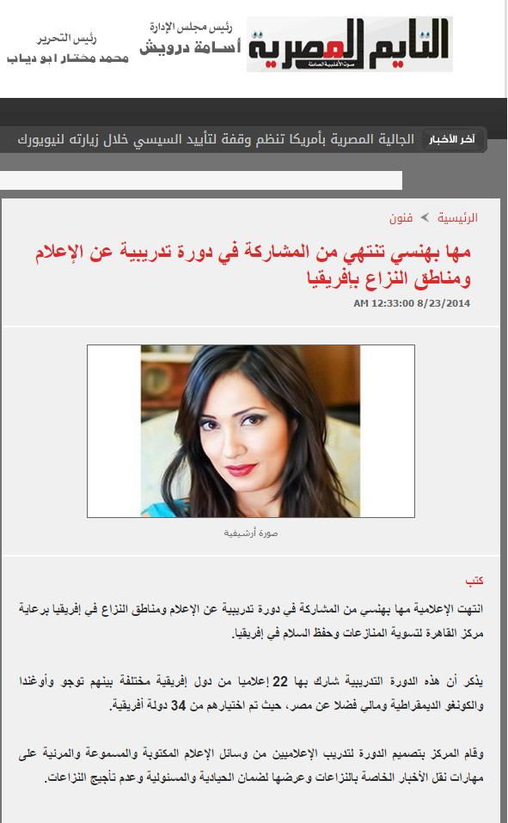
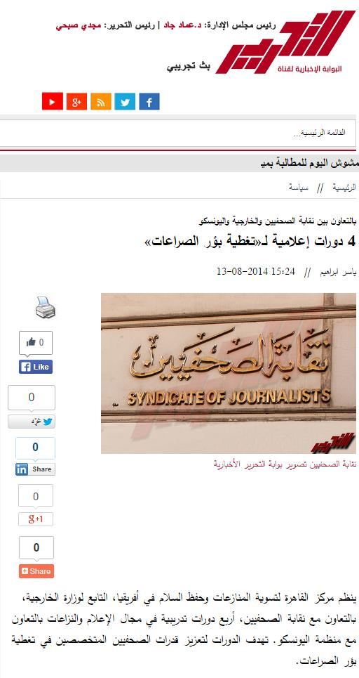

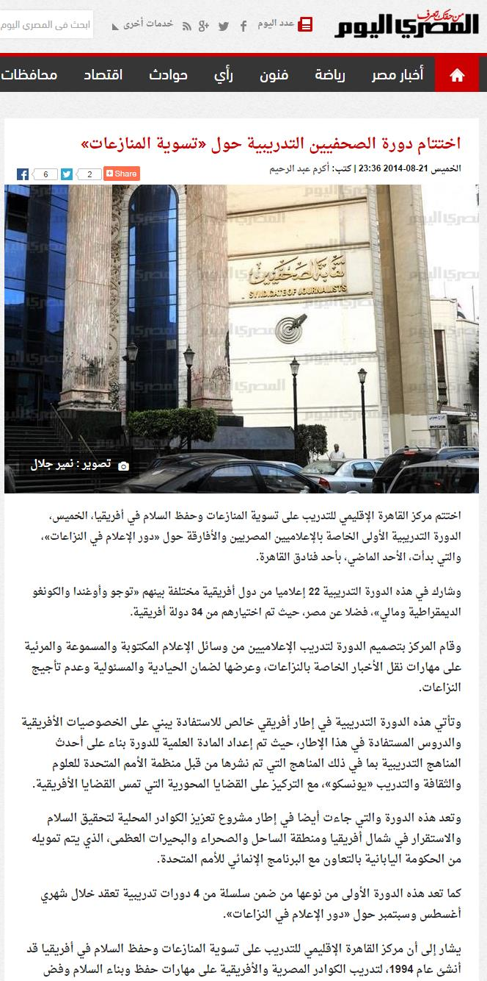

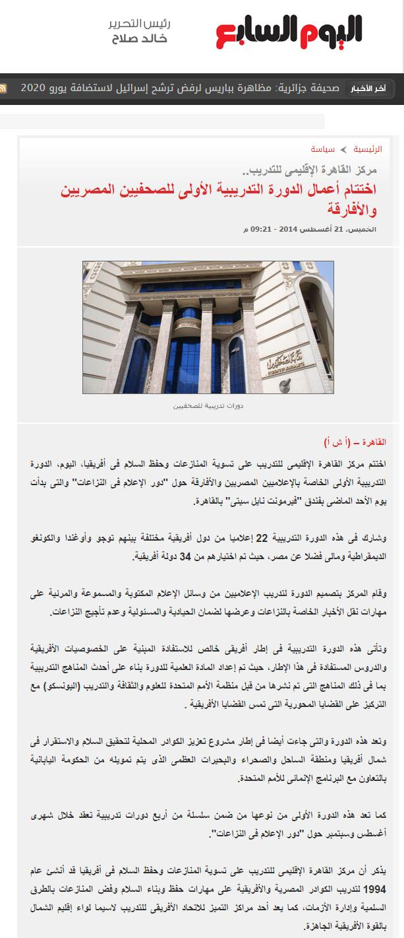

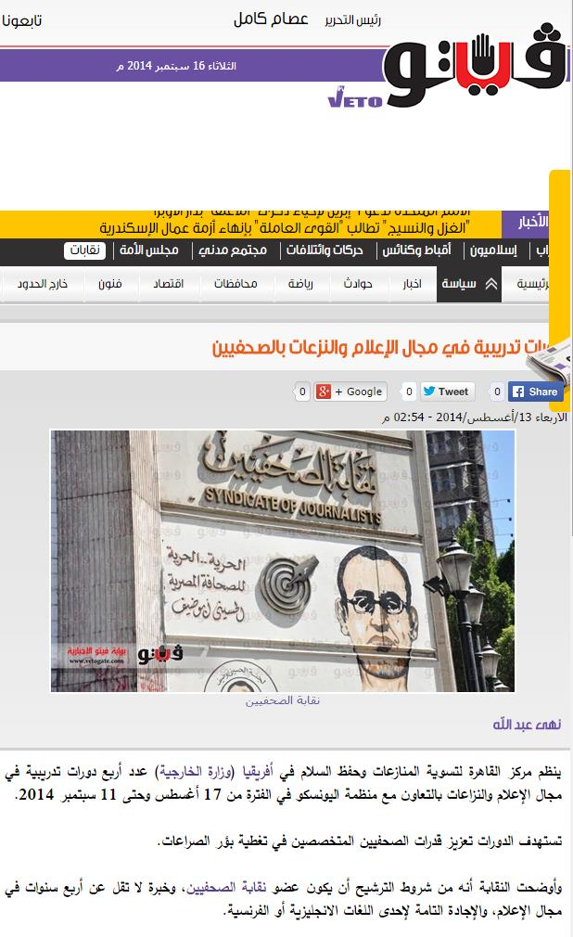

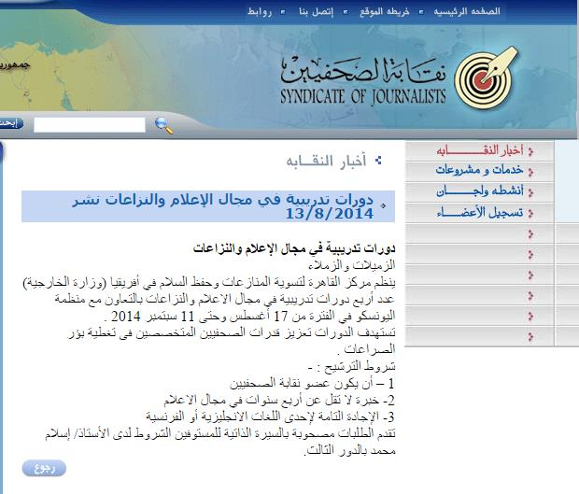

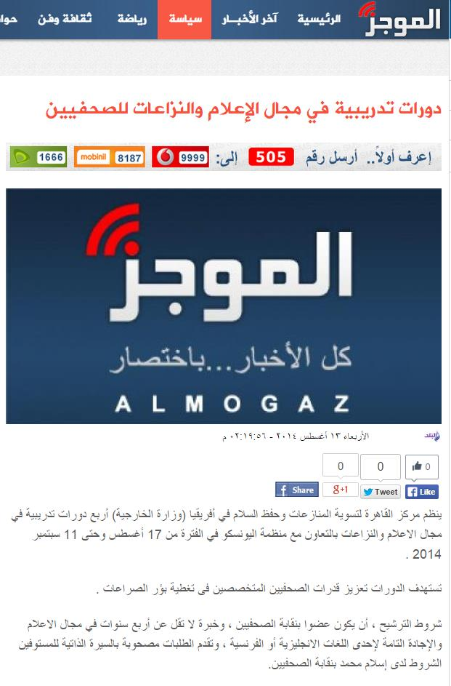
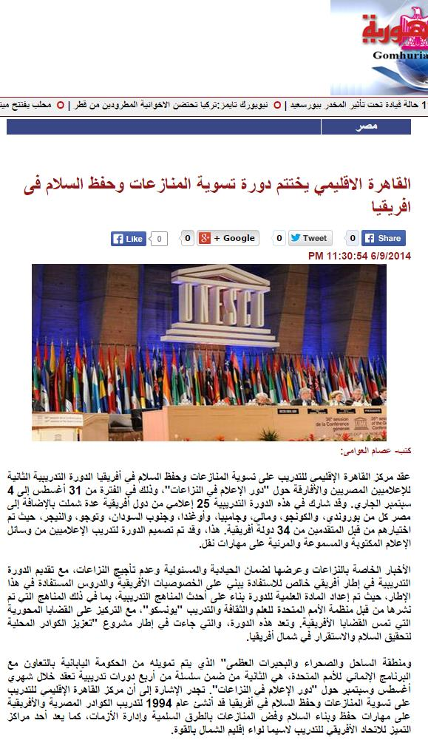
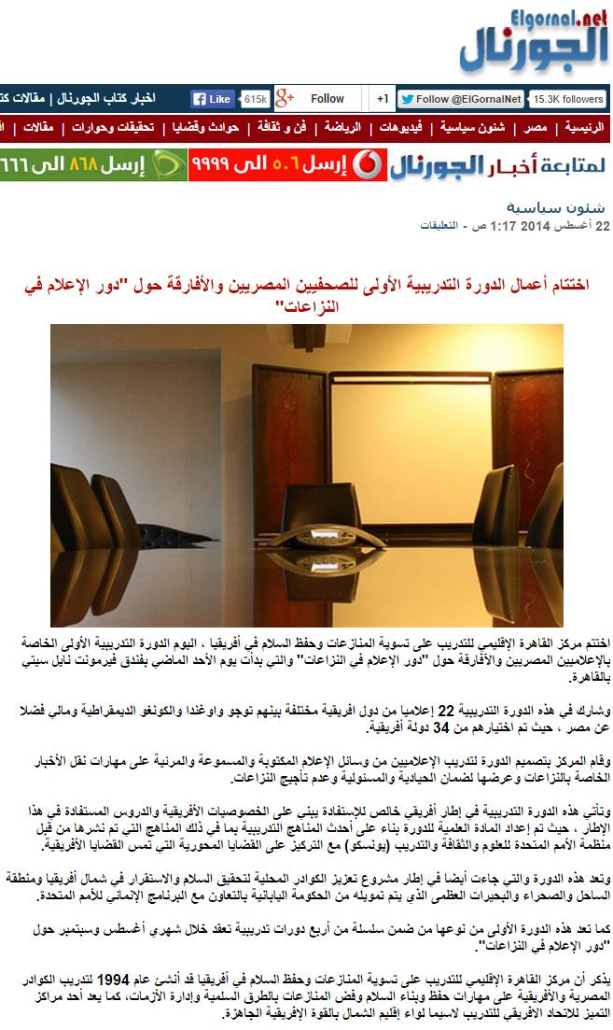
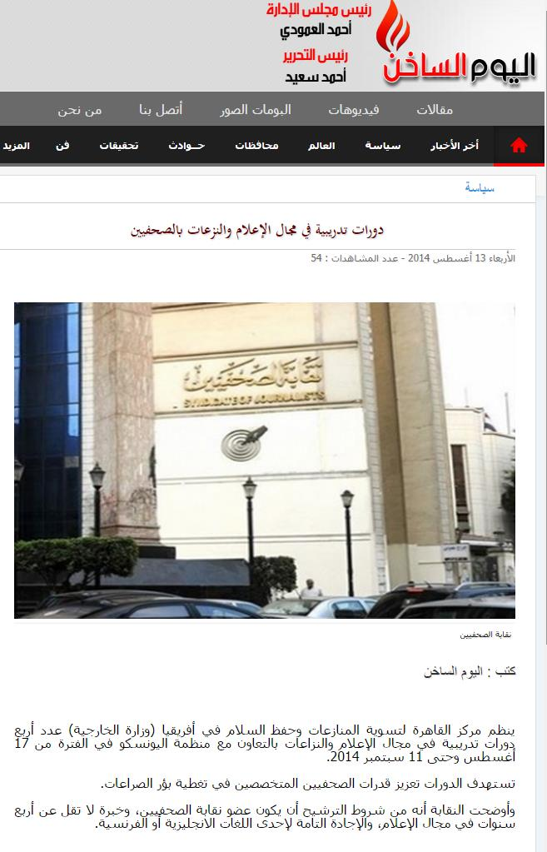
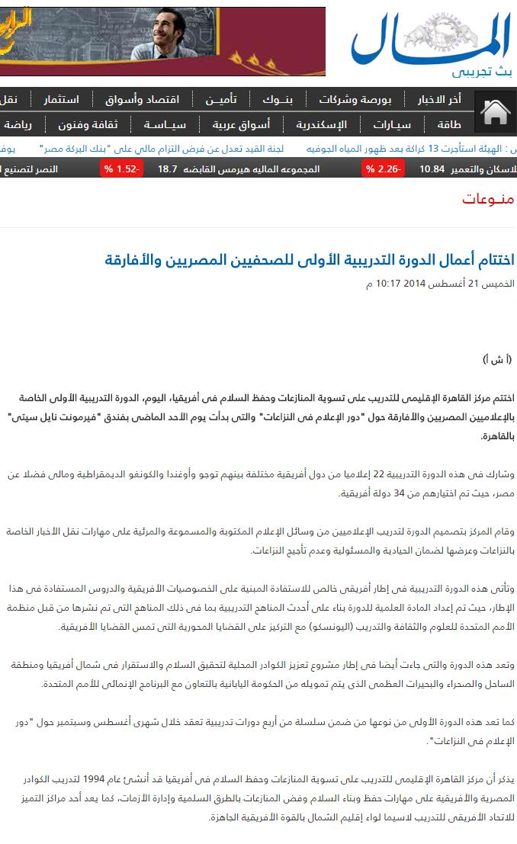

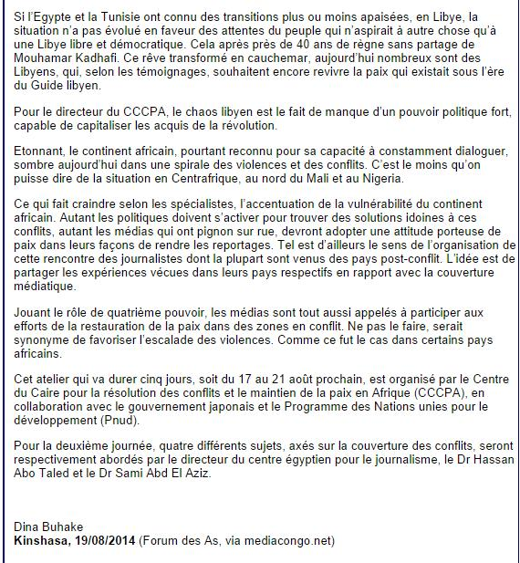

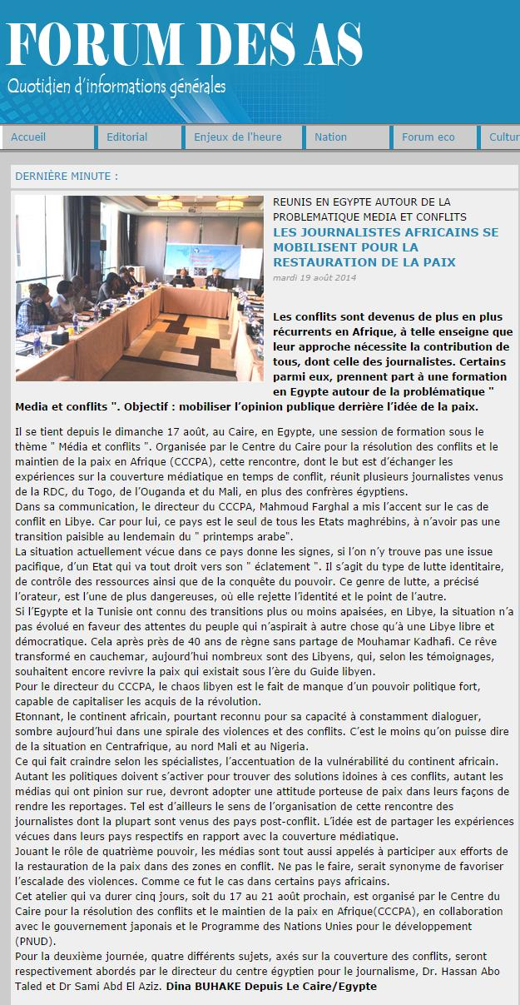

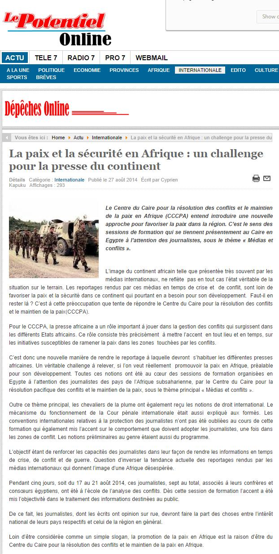
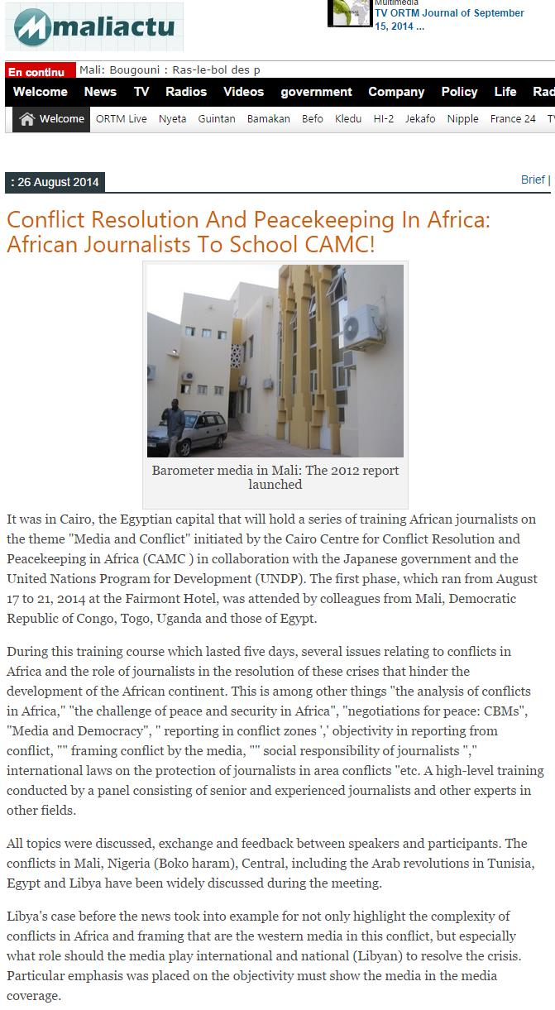

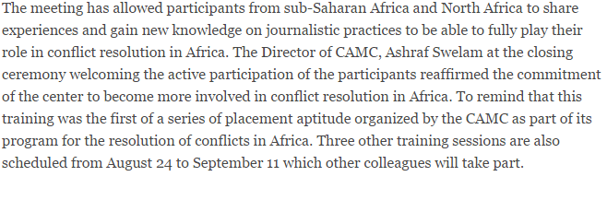

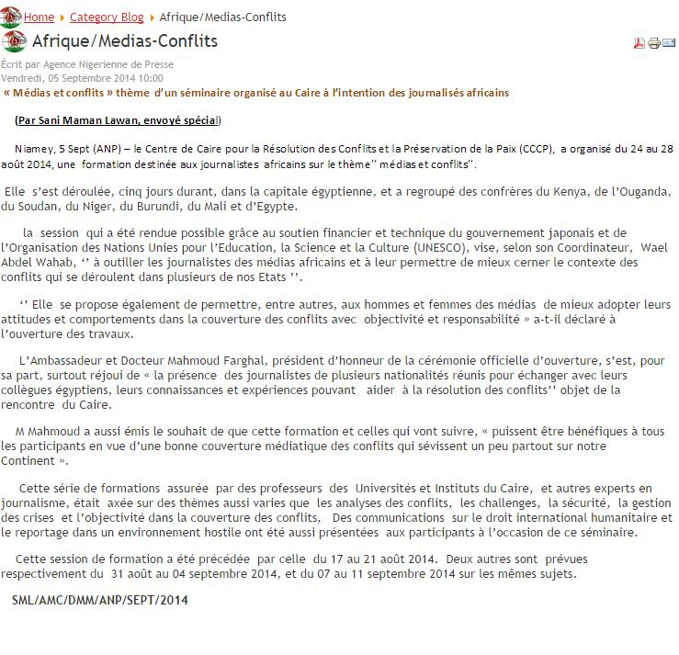

According to CCCPA accounts, there are committed expenditures in the amount of $145,388.57 which relate to activities conducted during the period from June-August 2014 and which are yet to be finalized and reflected in UNDP financial reports.

